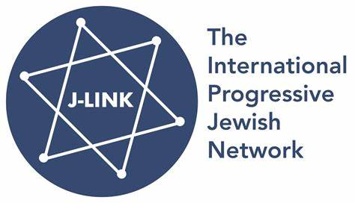
www.jlinknetwork.org
April 23, 2025
J-Link Response in Support of the Statement by 36 Members of the British Board of Deputies
J-Link, an international network of progressive Jewish organizations spanning multiple continents (www.jlinknetwork.org), stands in full support of the 36 members of the Board of Deputies of British Jews who recently signed a letter to the Financial Times.
It is important to note that these deputies acted in their capacity as elected representatives, not as spokespeople for the Board as a whole. In a democratic institution, it is fundamental that elected officials are able to voice their personal and constituency views, even, or especially, when those views diverge from official leadership positions.
The perspectives expressed in the letter are not isolated. On the contrary, they reflect the views of a significant segment of the Israeli public as well as of Jewish communities throughout the Diaspora. Multiple independent polls have consistently indicated that approximately 70% of Israelis support a negotiated agreement that would both bring an end to the current conflict and secure the safe return of all hostages held in Gaza.
It is therefore vital that the Board of Deputies, as the representative body of British Jewry, upholds its commitment to reflect the diversity of opinion within the community. Suppressing dissenting voices or sidelining alternative perspectives undermines the principles of democratic representation and stifles necessary debate. At a time of profound challenge and division, the community’s leadership must demonstrate openness to a plurality of views, ensuring that all members feel heard and represented.
Now, more than ever, is the moment to stand up for democratic values within our communal institutions, and to safeguard the space for open and respectful discussion.
Respectfully,
The J-Link Coordinating Committee
Barbara Landau (JSpaceCanada), Ken Bob (New Jewish Narrative, U.S.A.), Basil Dubb (JDI, South Africa), Giorgio Gomel (JCall Europe, Italy), Alon Liel (PWG, Israel), Shlomo Slutzky (J Amlat); Sebastian Levi (France), Ella Taylor Fagan (England)
J-Link is an international network of progressive Jewish organizations. We share a love of Israel and a commitment to democracy, human rights, religious pluralism, and a peaceful resolution of the Israeli-Palestinian conflict. We believe in the values enshrined in Israel’s Declaration of Independence, which promise “complete equality of social and political rights to all its inhabitants irrespective of religion, race or sex.”

