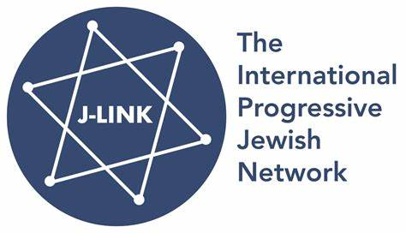
July 14, 2025 www.jlinknetwork.org
NOT IN OUR NAME!!
The J-Link Coordinating Committee is calling on the international community to raise their voices in support of human rights and democracy as we witness a humanitarian disaster with no end in sight. We are asking for:
- A permanent ceasefire NOW and a clear plan for withdrawal of Israeli military forces from Gaza
- Return of all hostages
- Restoration of UN sponsored humanitarian aid
- Implementation of the Egyptian/Arab League Plan to manage Gaza – without Hamas participation
- A stepwise commitment to recognize a Palestinian State with security guarantees and elections in the West Bank and Israel, with all candidates agreeing to uphold the rule of law and international human rights.
J-Link’s goal is a secure, just and peaceful future for both Israelis and Palestinians that includes extending the Abraham Accords as a roadmap to a promising Middle East future. After more than 75 years of conflict and so many lost lives, it is about time!
A recent Haaretz editorial, July 10, 2025, is a clarion call to oppose the tragic trajectory of actions being proposed by Israel and the U.S.. These plans include:
- Constructing an internment camp in Rafah– into which the population of the Gaza Strip would be constrained, with no ability to leave unless people "choose" to emigrate.; and
- Continuing Israeli military control as the world witnesses unrelenting attacks by the IDF on Gazans seeking humanitarian aid, killing many and injuring many more so that medical services are on the brink of collapse.
The Haaretz article concludes with a significant warning:
“The Gaza war has no military or diplomatic objectives, other than unacceptable ones: a second Nakba and/or a "voluntary" transfer of all Palestinians. This war must be stopped immediately. The hostages must be brought back, and the army must withdraw from the enclave. Control must be transferred to the Palestinian Authority within an Arab-international framework, and the rebuilding of the Strip must be allowed to begin. One cannot lend a hand, whether by assent, silence or indifference, to a plan over which a black flag is fluttering. “
J-Link is calling on world leaders to speak out for a true path to PEACE and against the proposals being advanced by the Israeli government.
Respectfully,
The J-Link Coordinating Committee
Barbara Landau (Canada), Ken Bob (New Jewish Narrative, U.S.A.), Basil Dubb (JDI, South Africa), Giorgio Gomel (JCall Europe, Italy), Alon Liel (PWG, Israel), Shlomo Slutzky (J Amlat), Ella Taylor Fagan (England)
J-Link is an international network of progressive Jewish organizations. We share a love of Israel and a commitment to democracy, human rights, religious pluralism, and a peaceful resolution of the Israeli/Palestinian conflict. We believe in the values enshrined in Israel’s Declaration of Independence, which promise “complete equality of social and political rights to all its inhabitants irrespective of religion, race or sex.” For more visit: www.jlinknetwork.org

